Carbody Structure and Exterior

Introduction

Use

Purpose

Parts List

All figures are assigned to an individual page unless views are required to show a complete listing of equipment.
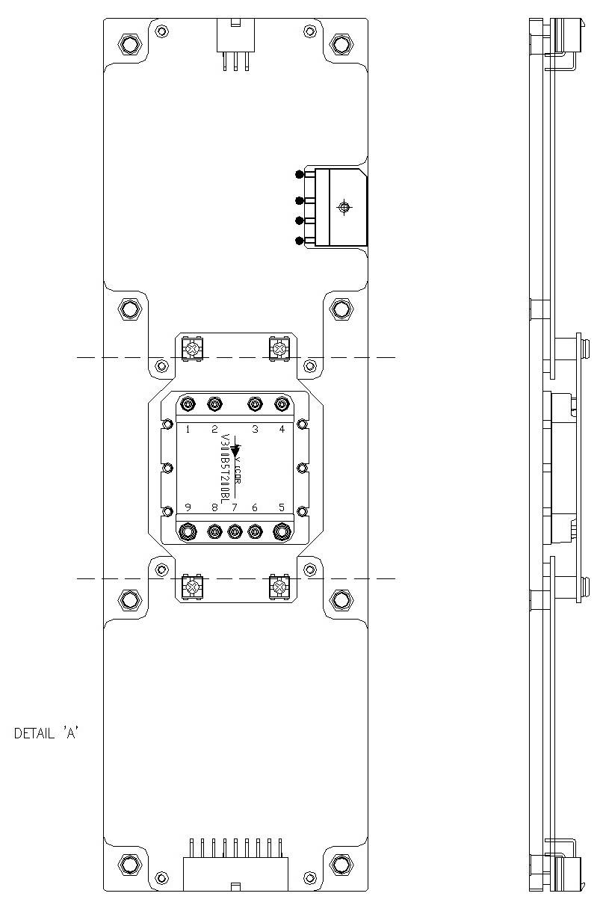

Figure 2.1. FDI_SDI Power Board3

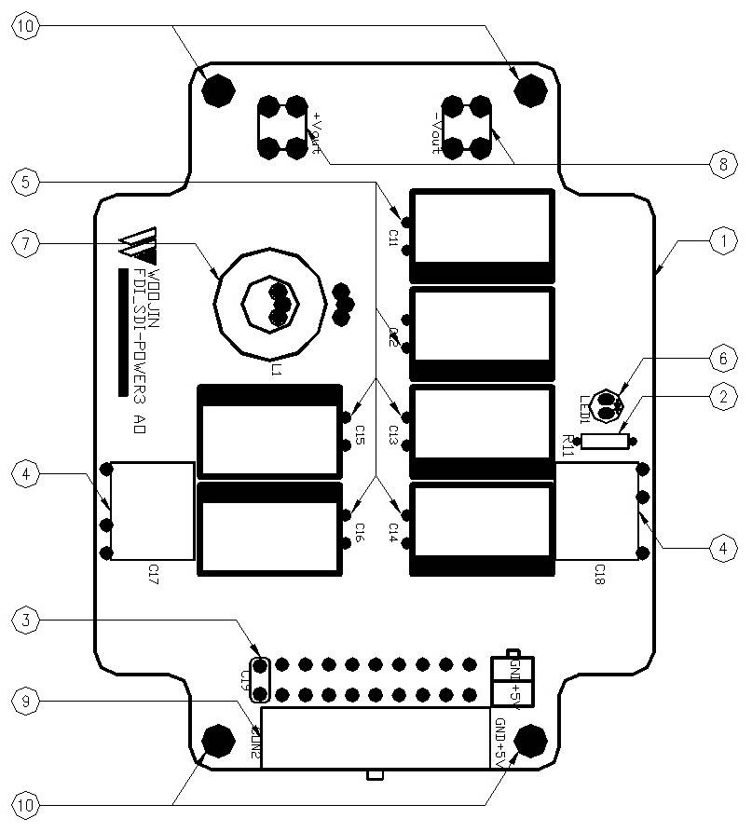

Figure 2.2.1. FDI_SDI Power Board3 (Detail A)

Table 1 - Figure 2.1. FDI_SDI Power board3
FIG No. | PART NUMBERS |  |  | ITEM DESCRIPTION | VENDOR CODE | QTY
 | HRC | VENDOR | DTP
1 |  | FDI_SDI-POWER3 A0 |  | . BOARD | HANSAEM | 1
2 |  | MRS1/4W2.2KΩFTB  MGR251/4W2.2KΩFTP  SN1/4KT52R2.2KΩF |  | . CARBON FILM RESISTOR | ABCO  RARA  JEIL | 1
3 |  | PCMT-365-85104  EB1J104K |  | . FILM CAPACITOR | PILKOR  SAMHWA | 1
4 |  | MPE630V222K |  | . FILM CAPACITORS | SUNGHO | 2
5 |  | KXL(LXZ)10VB1500M5.0TP  RD1A158M1012MPA |  | . ELECTROLYTIC CAPACITOR | SAMYOUNG  SAMWHA | 6
6 |  | 5GG4SD-01, HIGH  SM5311, Y-GREEN |  | . LED | DAGUANG  AUK | 1
7 |  | 4uH/10A, Φ20, CH203125 |  | . POWER INDUCTOR | TAESUNG  DAEKWANG | 1
8 |  | BR111, M3.5X8 |  | . SUPPORT | BEE RYONG | 2
9 |  | LAD1140-18P |  | . CONNECTOR | HANLIM | 1
10 |  | ROUND, M3XL6mm |  | . BOLT |  | 4

